Probability Tree Assignment

Task: Construct a tree diagram to calculate the outcomes and probability and the given event.

You can choose a topic/event of your choice (skittles, spinners, outfits, sports, etc.) Be creative ;)

You must include:
- A diagram
- A title
- A question/inquiry
- Labels (outcomes, percentages, fractions, etc.)
- Colours
- Final statement
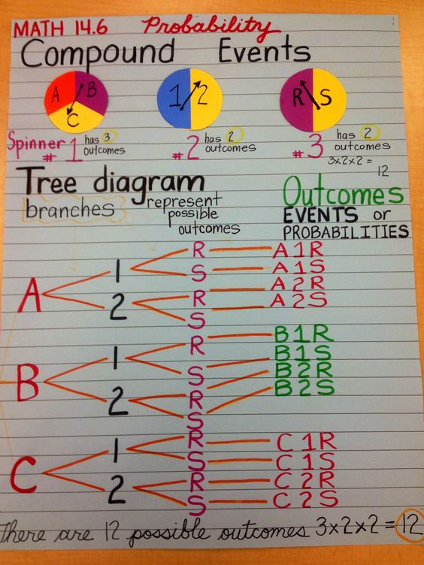
Example Do not copy this.

Due:

Monday May 28th

